**Image Processing of Damaged X-Ray Images**

**James Duxbury (bdzz75)**

## Overview

This report explores the use of image processing techniques on 100 damaged x-ray images to enhance their visual quality and boost a classifier's accuracy (initially 0.55).

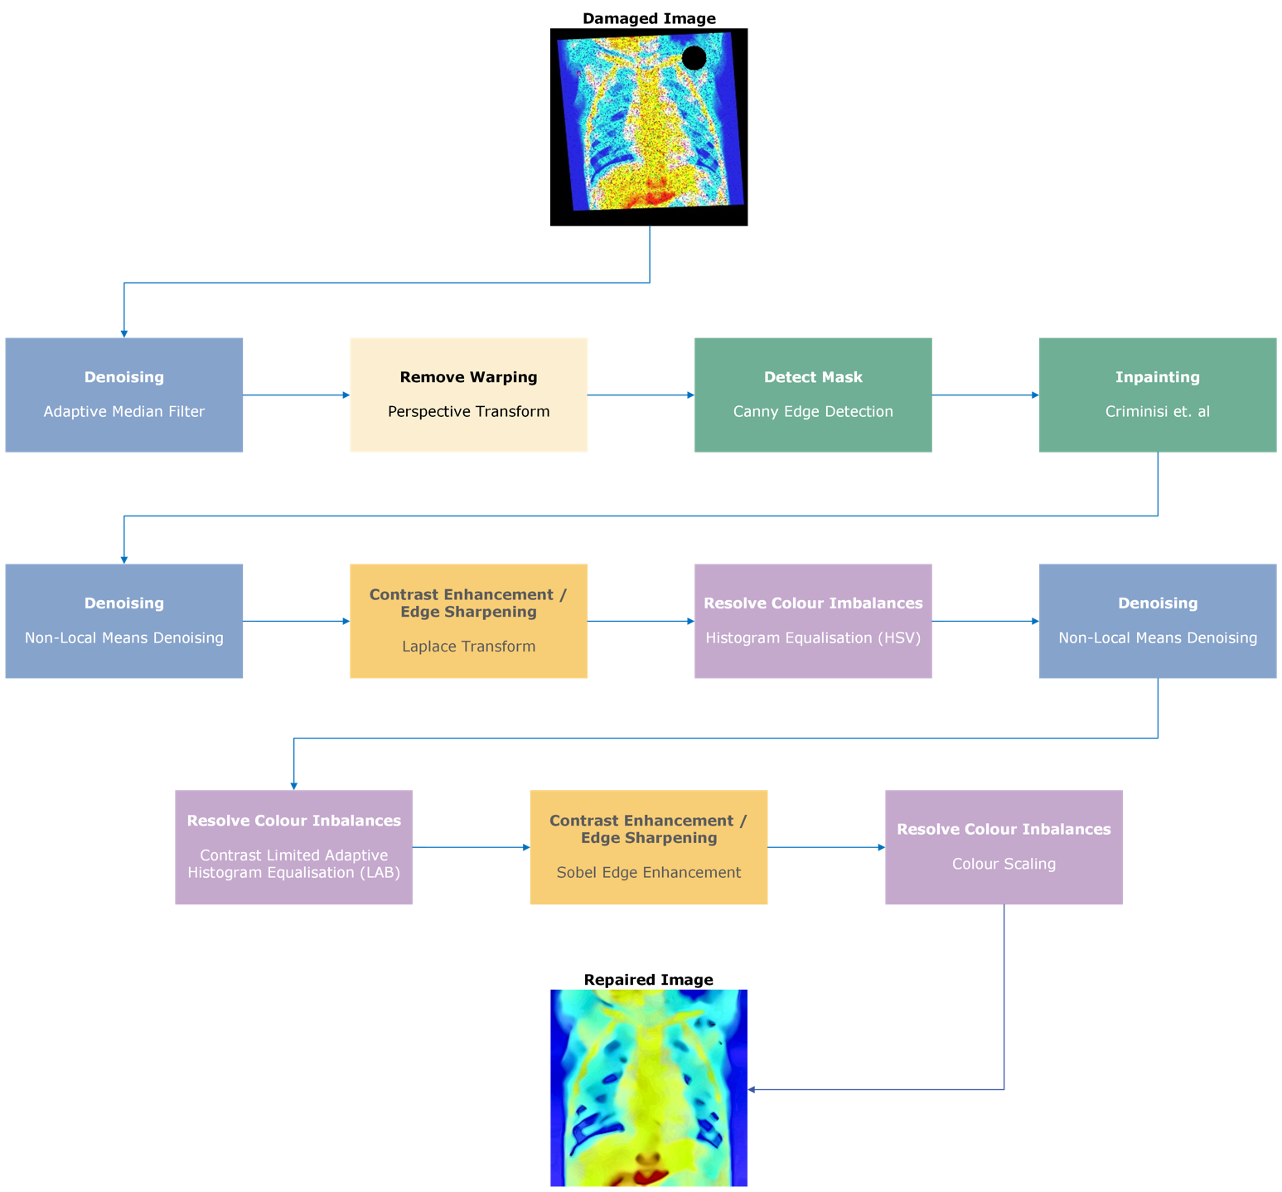Fig.1 outlines the proposed method.

Fig. 1 - Overview of the process completed to repair the damaged images.

## 2.0 Image Processing

### 2.1 Adaptive Median Filter (AMF)

Significant noise posed a feature-preservation/noise-removal trade-off. While salt-and-pepper noise is commonly addressed using a median filter, this caused excessive blurring.

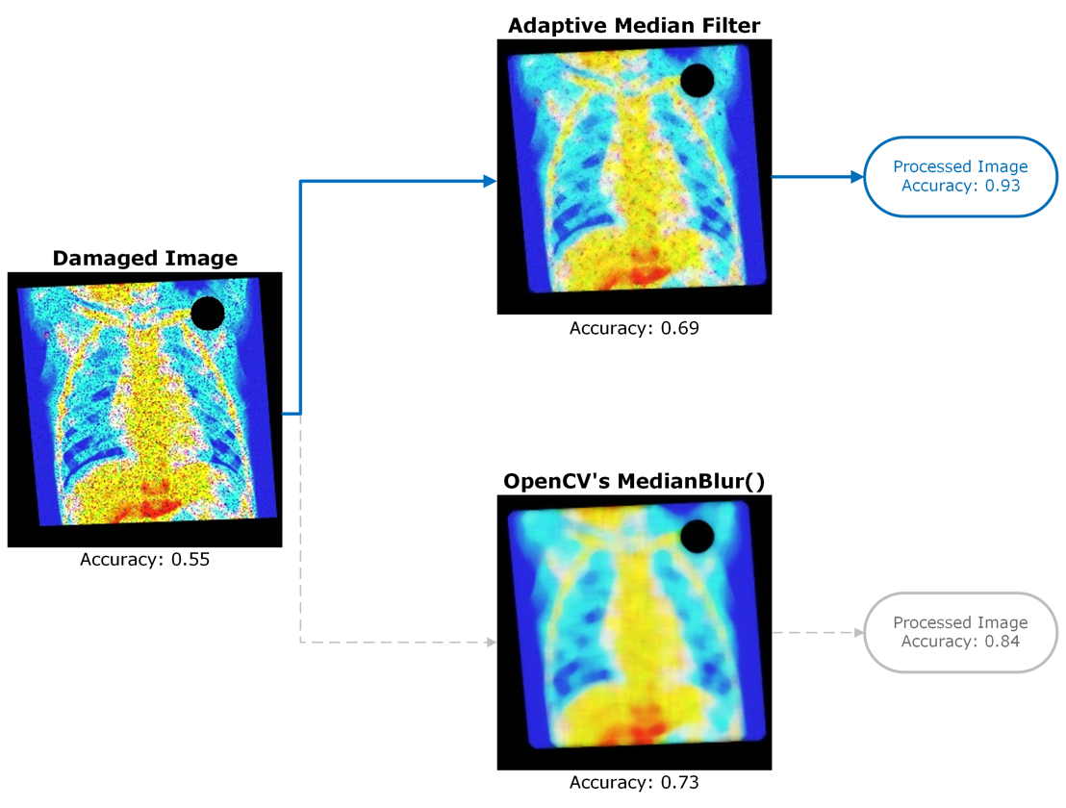A custom Adaptive Median Filter (AMF) was implemented, which updates a pixel only if it deviates more than a threshold from its neighbours.

Fig. 2 - Comparison between my adaptive median filter and OpenCV's MedianBlur()

### See Fig.2; despite less efficacy in removing salt-and-pepper noise, compared to MedianBlur(), AMF demonstrated superior feature preservation. Overall, the classifier performed 9% better with AMF.

### 2.2 Projective Transforms

A projective transform was used to remove warping.

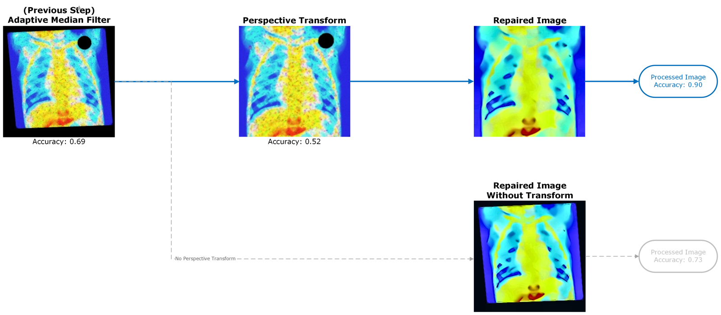

Fig. 3 - Analysis of Perspective Transform

Following AMF, accuracy was 0.69, which regressed to 0.52 following the transform. However, accuracy based on final processed images is 17% greater with the transform applied.

The transform also enhances visual quality. Without this, the edges bleed, potentially leading to information loss.

### 2.3 Canny Edge Detection

A systematic approach was employed to produce the mask for inpainting. Each image was converted to grayscale, before the top-right was extracted as the region-of-interest (ROI). This selection reduced any errors found from larger contours within the image, specifically from the base of the lung, affecting the mask.

Canny edge detection was applied to the ROI, identifying areas with high gradients, indicating edges. The detected edges were transformed into contours, with the largest contour being selected. A circle slightly larger than the contour was produced to ensure sufficient coverage of the area.

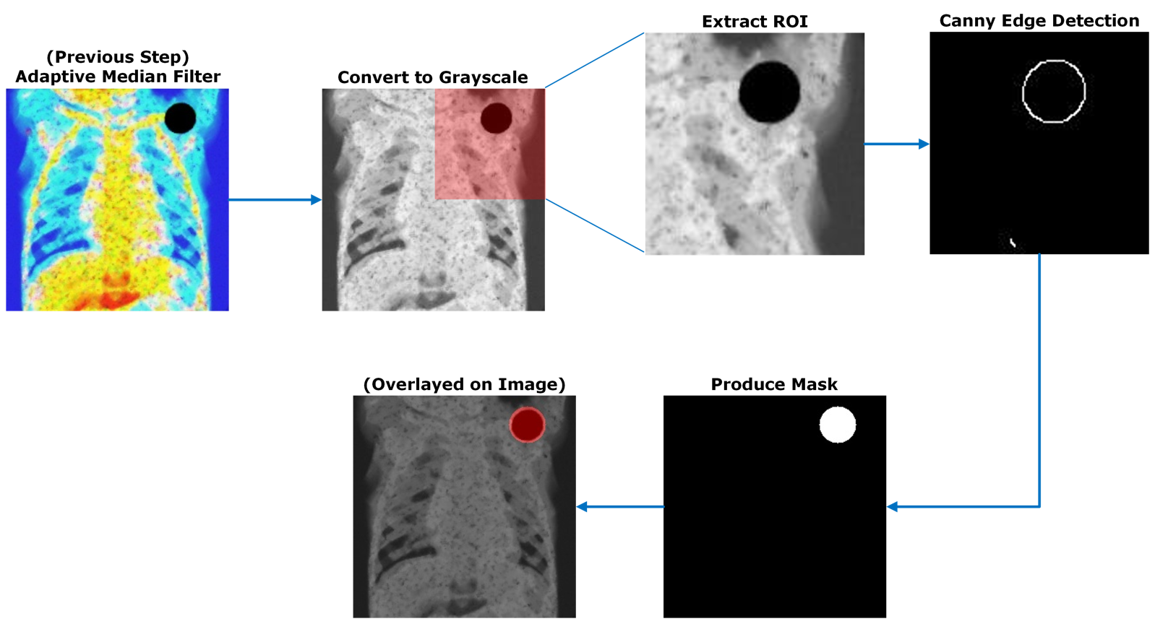

Fig. 4 – Diagram outlining the process of using Canny edge detection to produce masks for inpainting.

The thresholds used for Canny mitigated noise whilst preserving the contour’s integrity.

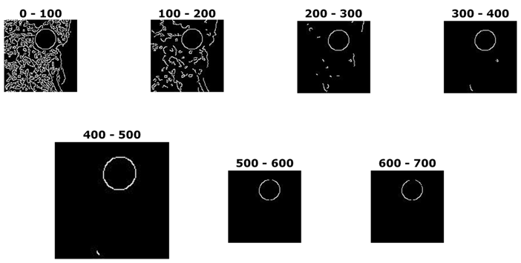

Fig. 5 – Edges detected between different thresholds using Canny() on im001-healthy.jpg. As can be seen, 400-500 reduces noise just enough, without removing too much of the main circle, allowing for an accurate region to be drawn.

This method produced exemplary results.

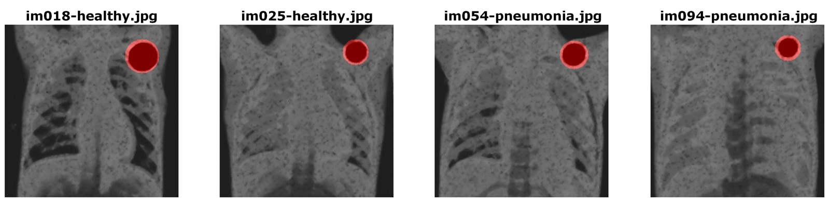

Fig. 6 – Overlaying the detected mask over greyscale images to show accuracy

### 2.4 Inpainting

Inpainting was achieved using a modified implementation [1] of the algorithm proposed by Criminisi [2], which uses exemplar-based inpainting by using isophotes to extend linear structures. The algorithm produces hyper-realistic results.

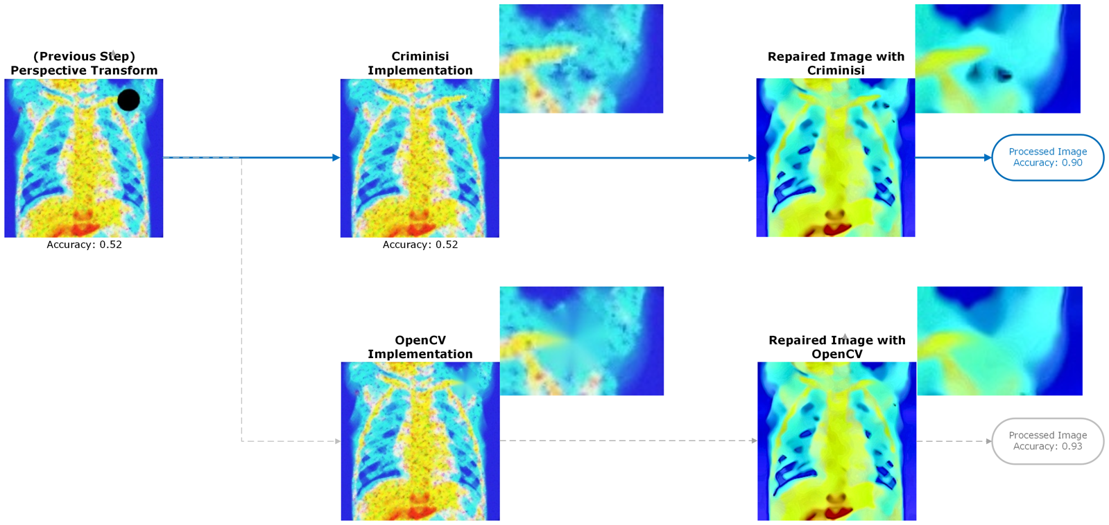

Fig. 7 – Analysis of the use of Criminisi’s algorithm with that of OpenCV’s inbuilt method.

See Fig.7, Criminisi’s algorithm provides superior inpainting, compared to OpenCV’s inbuilt methods. The collarbone is plausibly extrapolated, and the missing region becomes hard to discern. OpenCV’s method is non-realistic. Despite the remarkable increase in visual quality, Criminisi’s method achieved an intermediate accuracy of 0.52 (marking no improvement from the previous step), whereas OpenCV’s method produced an intermediate accuracy of 0.83. Final accuracy shows that my method achieved 0.9, but OpenCV’s would have achieved 0.93.

**On a MacBook Pro M1, image processing takes approximately 3 hours. Therefore, it is advised to allow sufficient time.**

### 2.5 Non-Local-Means Denoising

Despite AMF removing substantial salt-and-pepper noise, substantial remained. This was improved with a Non-Local-Means (NLM) denoiser. NLM works by dividing the image into patches, comparing, and weighting their similarity. Noise is then removed from patches by replacing pixels with the weighted average of similar patches.

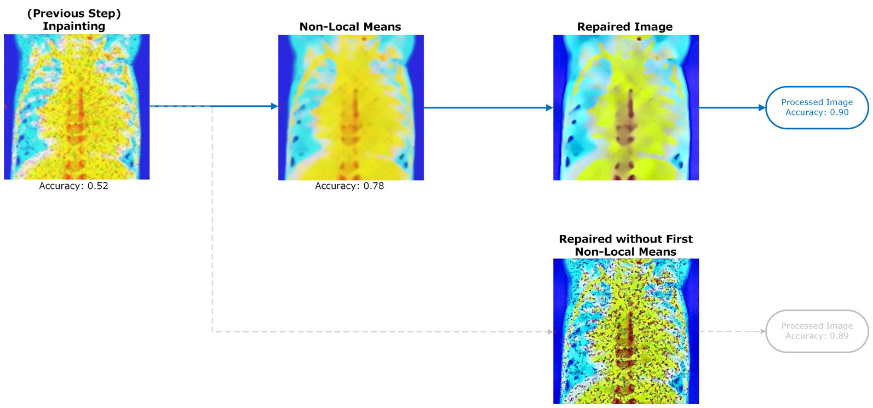

Fig. 8 – Analysis of the use of NLM on im051-pneumonia.jpg

See Fig.8; NLM removed almost all noise, at the expense of lost clarity. Colours appear muted, with not well-defined edges. However, the image is extensively improved. The final repaired image with the first NLM present is only 1% more accurate than without, however not including the first NLM leads to the remaining salt-and-pepper noise being amplified, severely impacting quality.

### 2.6 Laplace Transform

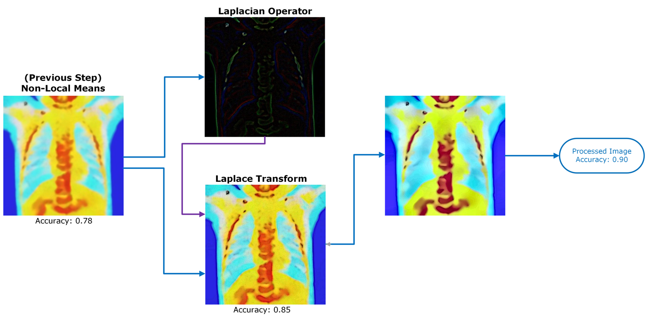Applying the Laplacian Operator on each image, and subtracting this improved contrast. As can be seen in Fig.9, this improved visual quality, with a slight reintroduction of noise.

Fig. 9 – Overview of Laplace Transformation on im028-healthy.jpg

## 2.7 Histogram Equalisation in the YCrCb Colour Space

To improve contrast and colour perception, I first completed histogram equalisation in the YCrCb colour space, specifically the Cb colour channel.

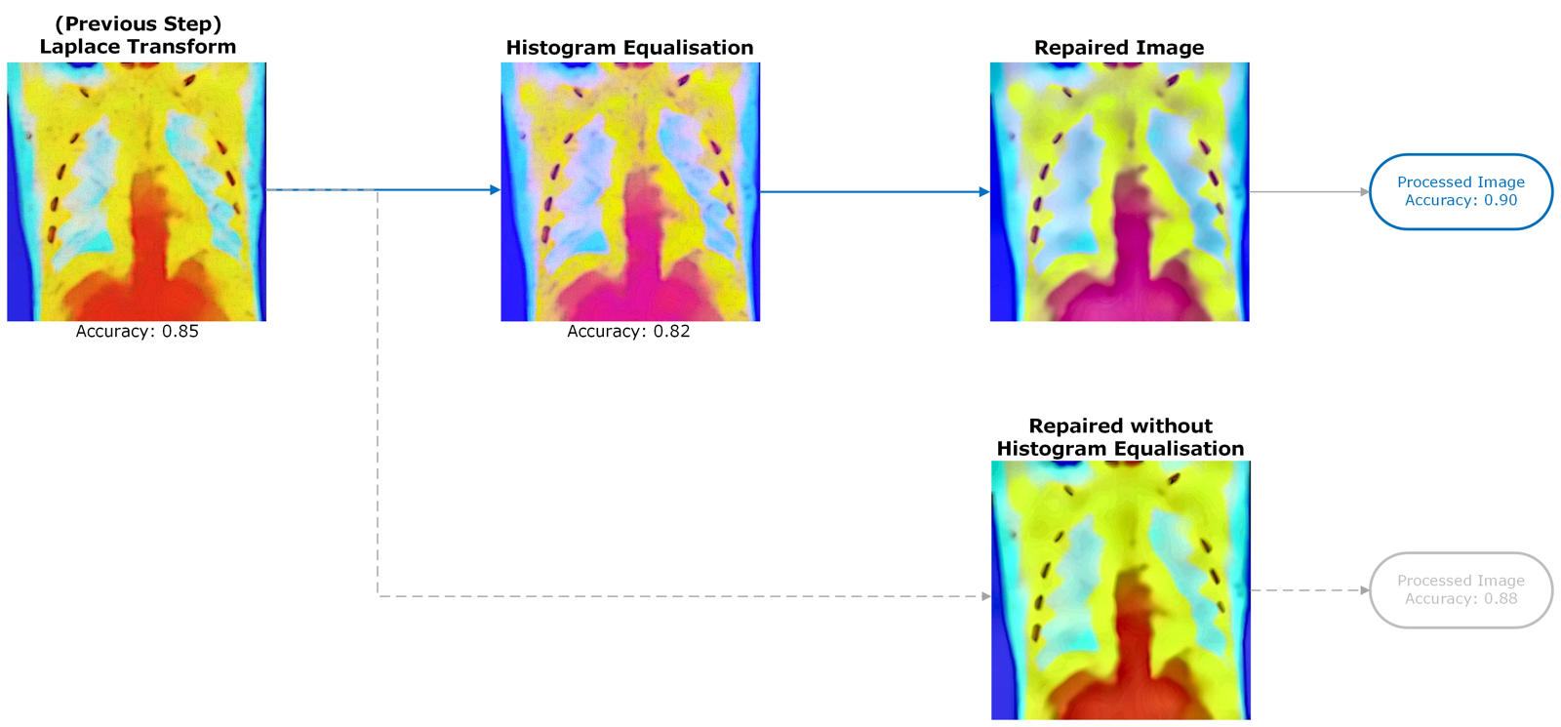

Fig. 10 – Application of Histogram Equalisation on im007-healthy.jpg

### 2.8 Reapplication of Non-Local Means Denoising

Small amounts of gaussian noise were reintroduced, which NLM removed. This depicts NLM’s versatility against different noise, compared to traditional methods. Noise was suppressed, compared to images without the second reapplication, despite classifier accuracy being 1% lower.

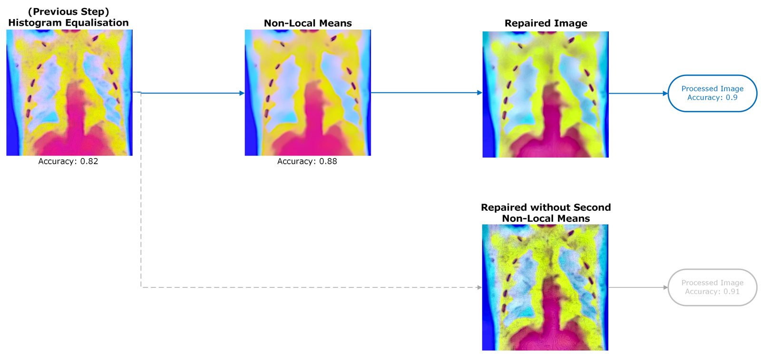

Fig. 11 – Second application of NLM on im007-healthy.jpg

### 2.9 Contrast Limited Adaptive Histogram Equalisation in the LAB Colour Space

CLAHE was used to further contrast-enhance. CLAHE partitions the image into tiles, equalising each, preventing excessive enhancement through contrast limiting. Using the LAB colour space allowed focus onto the 'Lightness' channel, avoiding unintended colour distortions. This approach facilitated a more uniform colour distribution.

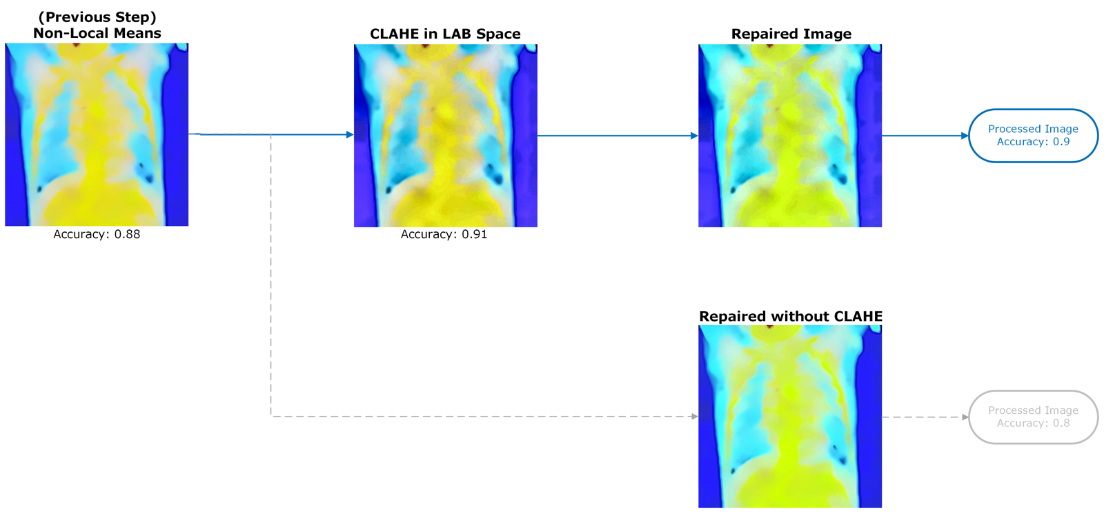

Fig. 12 – Application of CLAHE on im011-healthy.jpg

### See Fig.12; the repaired image is darker than a repaired image without CLAHE, but performs 10% better.

### 2.10 Sobel Edge Enhancement

To further sharpen, I used Sobel, which calculated horizontal/vertical gradients and combined to compute the magnitude and direction of edges, which when combined with the original image, improved sharpness.

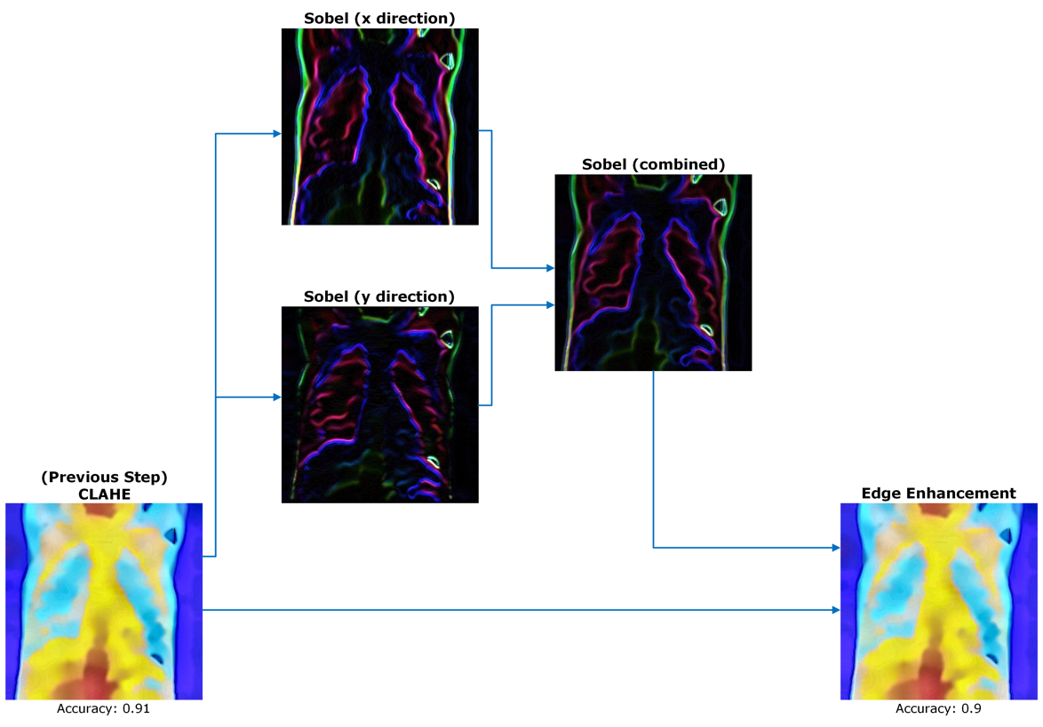

Fig. 13 – Sobel edge enhancement applied on im099-pneumonia.jpg

### 2.11 Colour Scaling

Despite attempts to resolve colour imbalances, reference distributions did not match those produced, which notably lacked green. Substantial repaired ‘healthy’ x-rays had pink or white regions, causing misclassifications. This was resolved by scaling the green and red colour channels.

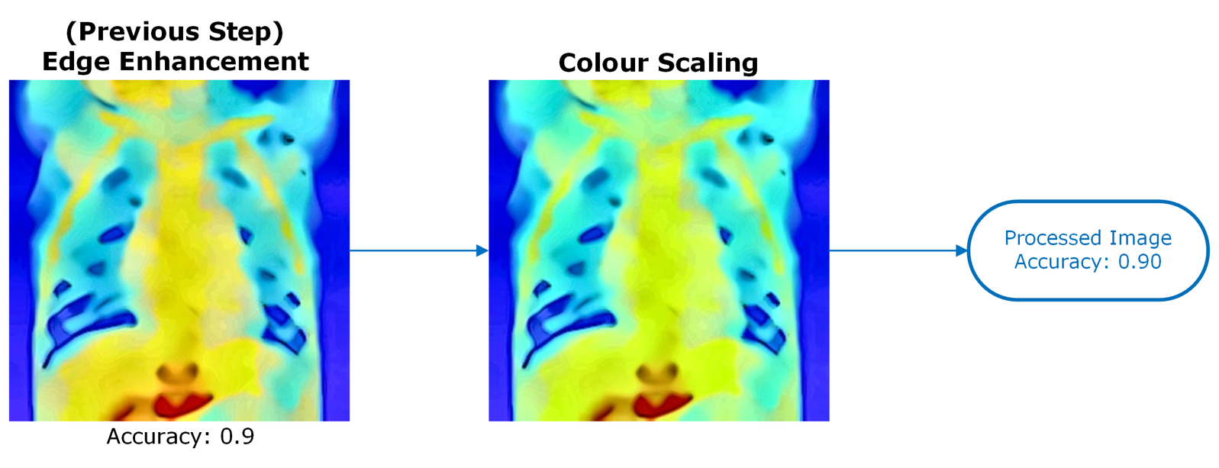

Fig. 14 – Application of colour scaling on im001-healthy.jpg

## 3.0 Analysis

The proposed method achieved an accuracy of 0.90, (0.93 with OpenCV’s inpaint()). I chose to use Criminisi inpainting, recognising the trade-off between visual quality and classifier accuracy – improved visual quality warranted a three-percent decrease.

### 3.1 Analysis of Classifier Accuracy

Fig.15 details the accuracy achieved for each intermediate step.

Fig. 15 – Analysis of classifier performance for each intermediate processing step.

### The proposed methods provide 35% improvement. Performance regressed the most during the projective transform, however moving this to a later stage would cause bleeding of the edges, and loss of image quality.

### A collage of images of a person's chest Description automatically generated3.2 Analysis of Image Quality

Fig. 16 – Comparison of damaged and repaired images, along with a reference image provided beforehand.

The proposed method has significantly improved visual quality. Warping and noise have successfully been removed, positive measures have been made to improve colour and contrast imbalances, and Criminisi’s method has allowed realistic inpainting.

# **4.0** **Bibliography**

|  |  |
| --- | --- |
| [1] | N. Nahar, “GitHub Repository,” 11 12 2021. [Online]. Available: https://github.com/NazminJuli/Criminisi-Inpainting. |
| [2] | A. Criminisi, P. Pérez and K. Toyama, “Region Filling and Object Removal by Exemplar-Based Image Inpainting,” *IEEE TRANSACTIONS ON IMAGE PROCESSING,* vol. 13, no. 9, 2004. |